 | 8.1.1 Editors - Image Editor - Header - Header Tools and Options
Table of content
Image Editor - Header Tools 2
Image Prop 2
List of images in the scene 2
Image Edit Box 2
Fake User 3
Search form 3
New Image 3
Name 3
Width 3
Height 3
Color 3
Alpha 3
Generated Type 3
32 Bit Float 3
Duplicate 4
Unlink Datablock 4
Fake User 4
Open Image 4
Unpack 4
User 4
Use Image Pin 4
Display Channels 4
Color and Alpha 4
Color 4
Alpha 5
Red 5
Green 5
Blue 5
Mask Prop 5
List of Masks 5
Mask Edit Box 5
Fake User 5
Search form 5
Create Mask 6
Unlink Datablock 6
Show Overlays 6
Overlays settings 6
Image 6
Show Metadata 6
Mask Display 6
Smooth 6
Overlay 6
Edge Display Type 7
Slot 7
Layers 7
Pass 7
Combined 8
Depth 8
Show Stereo 8
View 8
Options Panel 8
In View and Mask mode 8
Update Automatically 8
Show Metadata 8
In Paint Mode 8
Update Automatically 8
Show Metadata 8
Display Texture Paint UV's 8
Show same material 9

Image Editor - Header Tools

The header contains several tools, depends on what you do and what toolset is selected. The render result has some additional functionality.

Image Prop
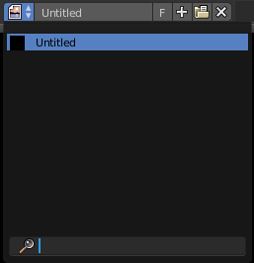
This property contains the list of loaded images. When no image is loaded then it displays the New and Open Buttons. When an image exists then it displays the name of the currently selected image.

From left to right ...

List of images in the scene
This is a list of the images in the scene. This list allows you to switch to other images.

Image Edit Box
Read the name of the currently selected image. And you can rename the image here too.

Fake User
Wit this button you assign a fake user to this selected image.
Data, like images, that is not longer linked to anything else gets removed when you save and reload a scene. Bforartists has the concept of fake users to go around this behavior. An image with a fake user is in fact linked to something. And so it is not lost when you save and reload the scene.

Search form
Search for specific images.

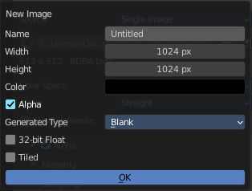
New Image
Create a new image.
Creates a new image. You will get a dialog where you can define settings for the new image.

Name
The name of the new image

Width
The width of the new image.

Height
The height of the new image.

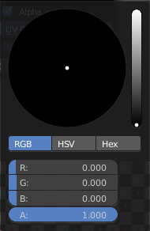
Color
Adjust the color of the new image. A click will call a color picker.

Alpha
Check this checkbox if the new image should have an alpha channel.

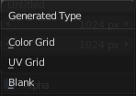
Generated Type
Here you can define what kind of texture you want to create.
Blank is one plain color.
UV Grid is a checker texture in black and white.
Color Grid is a colored checker texture.

32 Bit Float
Check this checkbox if the image should be in 32 Bit floating point bit depth per channel. Else it is in 8 bit per channel.

Duplicate
Not supported here.

Unlink Datablock
This deletes the selected image. Unfortunately not immediately. You need to save the scene and to reload it.
And you need to make sure that it is not linked to anything else. A mesh or a fake user for example. Have a look if there is a number besides the F button. When this is the case then the image has still a user, and so still loads with loading the scene.

Fake User
Wit this button you assign a fake user to this selected image.
Data, like images, that is not longer linked to anything else gets removed when you save and reload a scene. Bforartists has the concept of fake users to go around this behavior. An image with a fake user is in fact linked to something. And so it is not lost when you save and reload the scene.

Open Image
Opens the file browser to load an image.

Unpack
Unpack packed files to a directory.

User
The number of users that uses this data. Data with a user number of 0 will be removed with closing Bforartists.

Use Image Pin
When you select another object. for UV mapping for example, then usually the connected images for this object gets displayed. Use image pin nails the currently selected image so that it stays displayed.

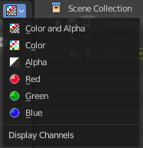
Display Channels
Adjust what channels of the image gets displayed.

Color and Alpha
Displays the whole image, including alpha channel.

Color
Displays the whole image, but without alpha channel.

Alpha
Displays the alpha channel of the image.

Red
Displays the red channel of the image.

Green
Displays the green channel of the image.

Blue
Displays the blue channel of the image.

Mask Prop
When you are in Mask mode then you can create a new mask, and work with this mask then.
Masks have many purposes. They can be used to mask out, or influence a particular object in the footage in Motion tracking. They can be used for manual rotoscoping to pull a particular object out of the footage. They can be used as a rough matte for green-screen keying.
Masks are independent from a particular image of movie clip, and so they can also be used for creating motion graphics or other effects in the compositor.
Masks can be driven over the time so that they follow some object from the footage. For example a running actor. This can be achieved with shape keys or parenting the mask to tracking markers.

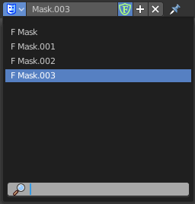
List of Masks
This is a list of the masks in the scene. Here you can switch to other masks.

Mask Edit Box
Read the name of the currently selected mask. And you can rename the image mask too.

Fake User
Wit this button you assign a fake user to this selected mask. Masks gets created with a fake user already. Means when you save the scene and reopen it, then this mask will still be there.
Data, like images, that is not longer linked to anything else gets removed when you save and reload a scene. Bforartists has the concept of fake users to go around this behavior. An image with a fake user is in fact linked to something. And so it is not lost when you save and reload the scene.

Search form
Search for specific images.

Create Mask
Adds a new mask.

Unlink Datablock
This deletes the selected mask. Unfortunately not immediately. You need to save the scene and to reload it.
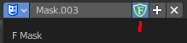
And you need to make sure that it is not linked to anything else. A mesh or a fake user for example. Have a look if there is a number besides the F button. When this is the case then the image has still a user, and so still loads with loading the scene.

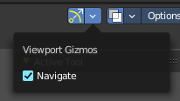
Show Gizmos
Display the viewport gizmos.
Navigate
Display the navigation gizmos in the Image Editor

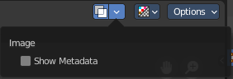
Show Overlays
Display the overlays in the viewport.

Overlays settings

Image

Show Metadata
Display existing metadata in the viewport.

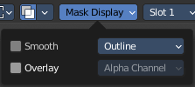
Mask Display
In Mask mode and with a Render result. Adjust the display of the mask.

Smooth
Smoothens the outline of the mask curve.

Overlay
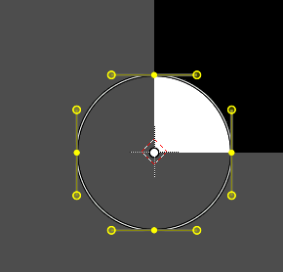
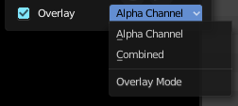
When it's a closed curve then this closed area gets displayed as filled where it covers the image. When you tick Overlay then the drop down box becomes active where you can choose the overlay method.

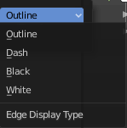
Edge Display Type
The mask curve can be displayed in different styles.

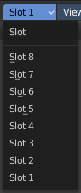
Slot
Just with a render result. Here you can render a new image into a new slot, which allows you to compare the two images then.
You need to render into this slot. So you need to choose it beforehand. Slots without a render result does not show the Render and Pass drop down boxes.
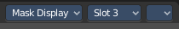

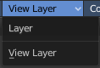
Layers
Here you can choose in which layer the render result is.
Renders can be separated into layers. This allows you to composite them back together afterwards.
For example blurring the background and foreground layers separately for depth of field, or rendering different lighting variations of the same scene.
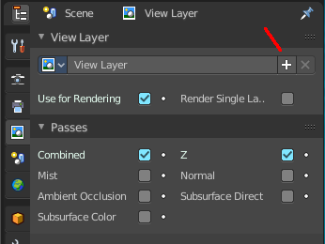
Using View Layers can also save you from having to re-render your entire image each time you change something, allowing you to instead re-render only the layer(s) that you need.
You can create more View Layers in the Properties editor. In the View Layer Tab.

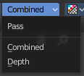
Pass
Here you can set the pass mode. Combined or Depth.

Combined
The final combination of render passes with everything included.

Depth
Just the Depth render pass.

Show Stereo
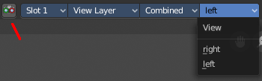
Just with stereoscopy enabled. Shows either the stereoscopic image. Or a single image from one of the cameras.

View
Show the image from one of the cameras in the list.

Options Panel
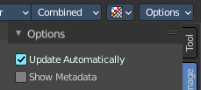

In View and Mask mode

Update Automatically
Update other editor windows simultaneously with the changes in the Image Editor.

Show Metadata
Draw Metadata properties of the image.

In Paint Mode

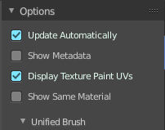
Update Automatically
Update other editor windows simultaneously with the changes in the Image Editor.

Show Metadata
Draw Metadata properties of the image.

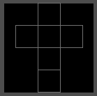
Display Texture Paint UV's
Display the UV wire from the active mesh. It needs to be in edit mode.

Show same material
This is for the case that you work at a texture for the current mesh. Just show faces of the mesh where the material with this texture is assigned to.

